2018-19
Jaskirat Kaur (UGC)
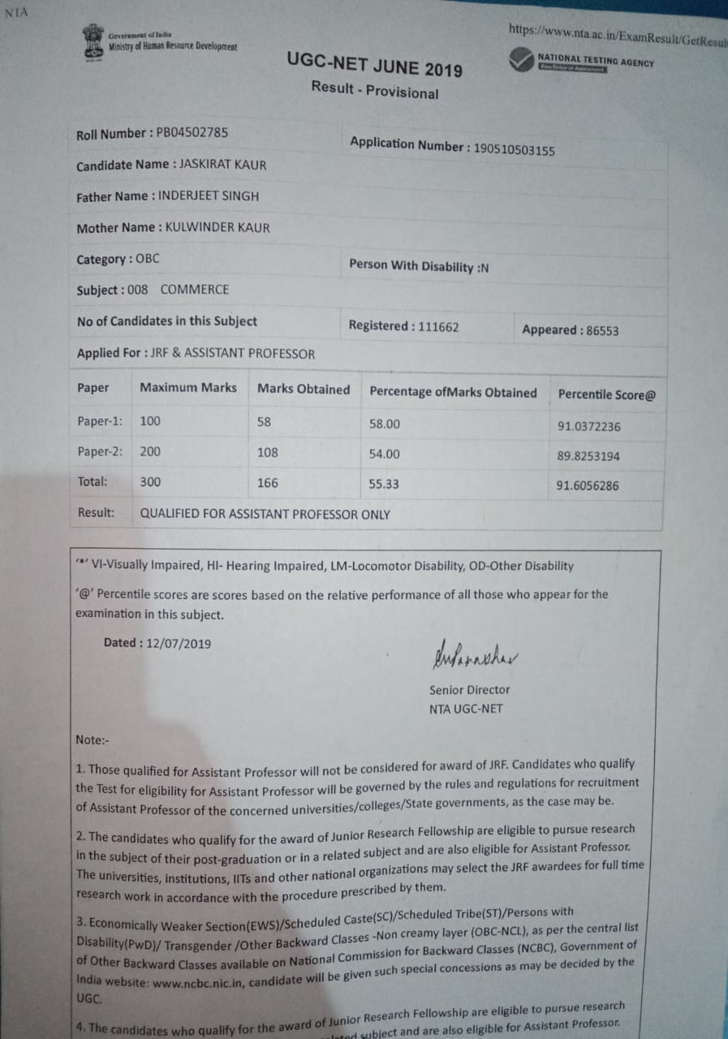

Shweta (IELTS)
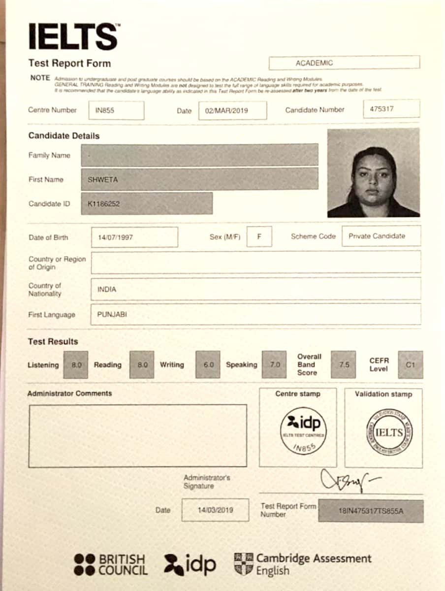

2017-18
Kiranbir kaur (JRF)
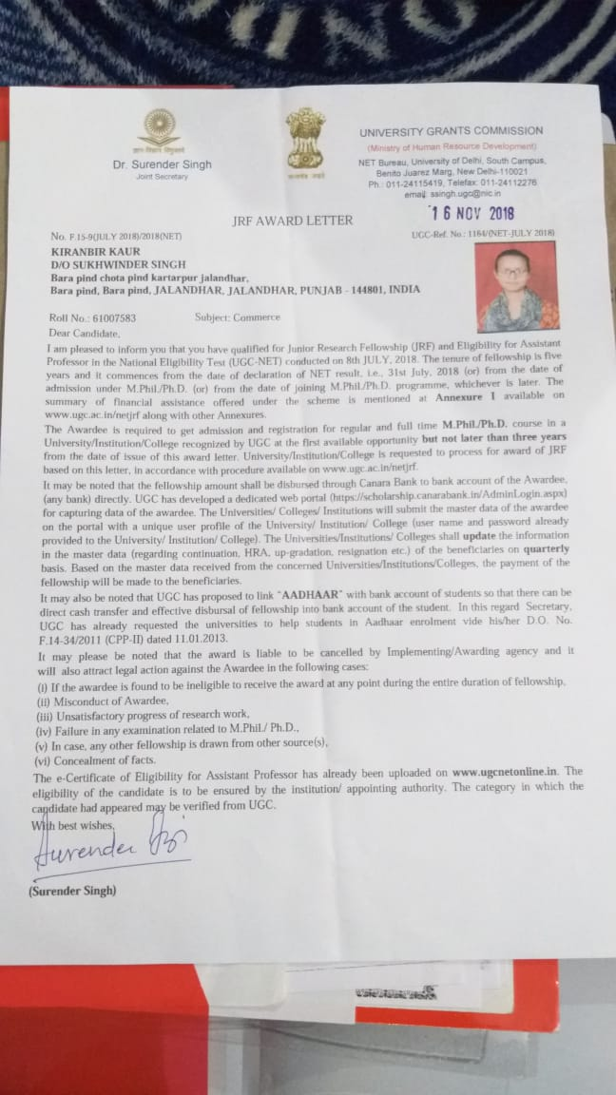

Upasana Seth (UGC)
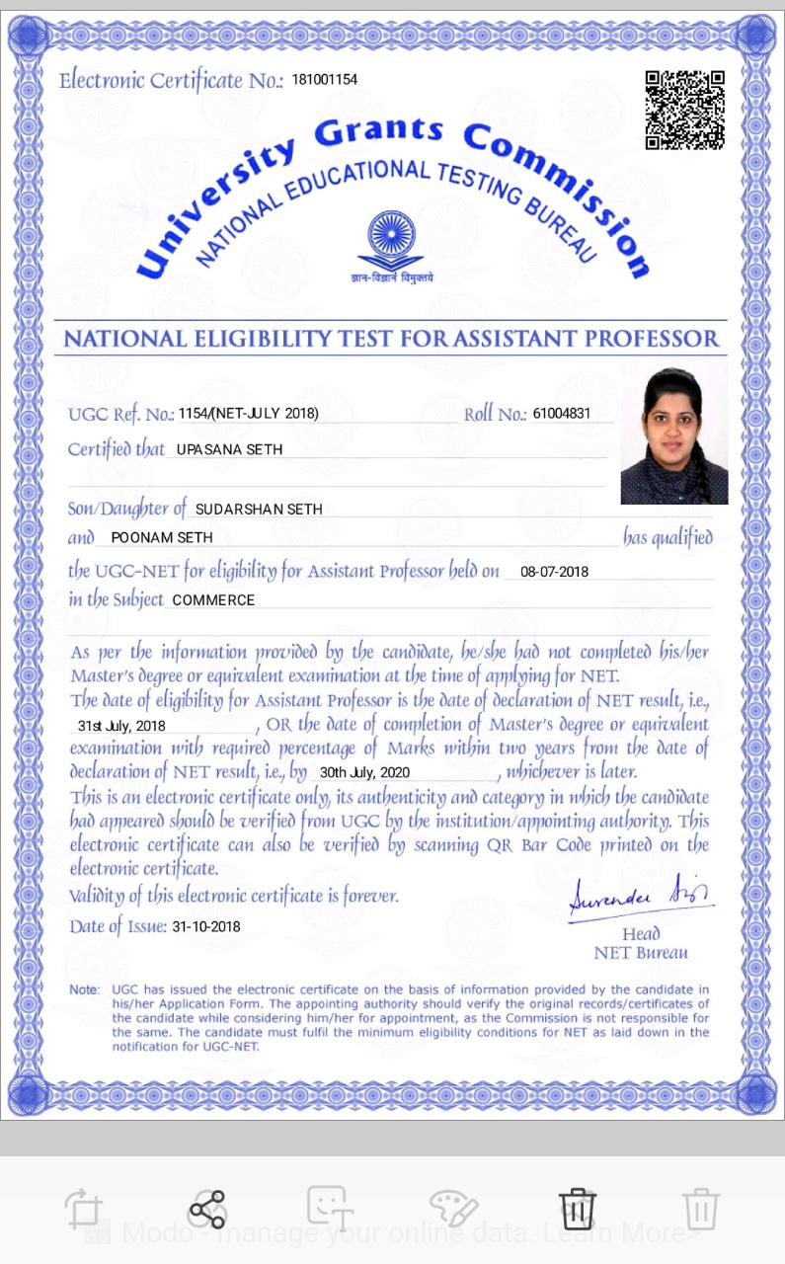
Kangan Sharma (CAT)
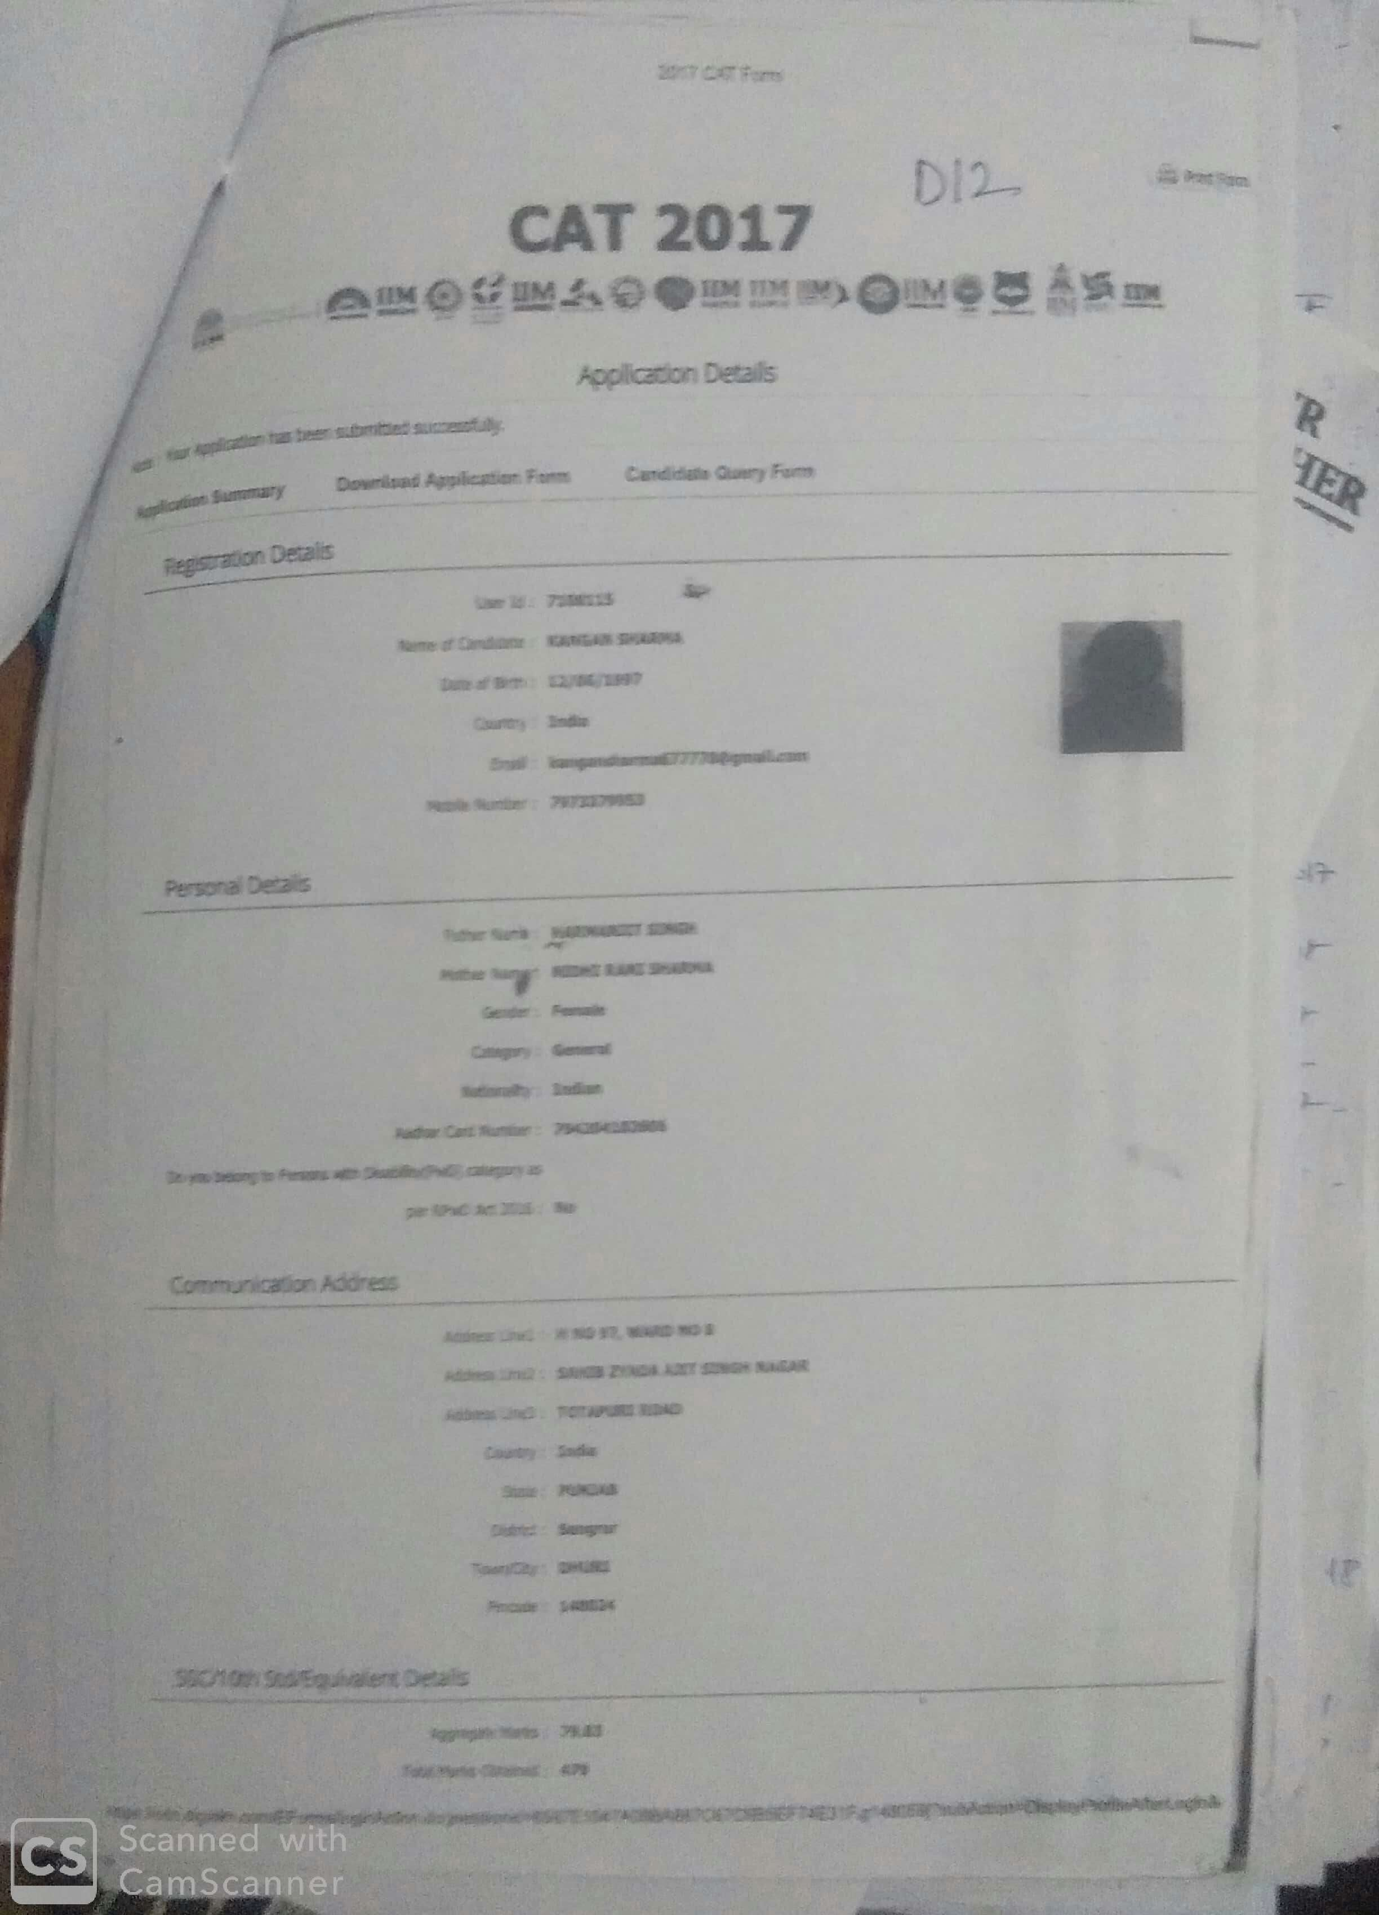

Prabhjeet Kaur (IELTS)
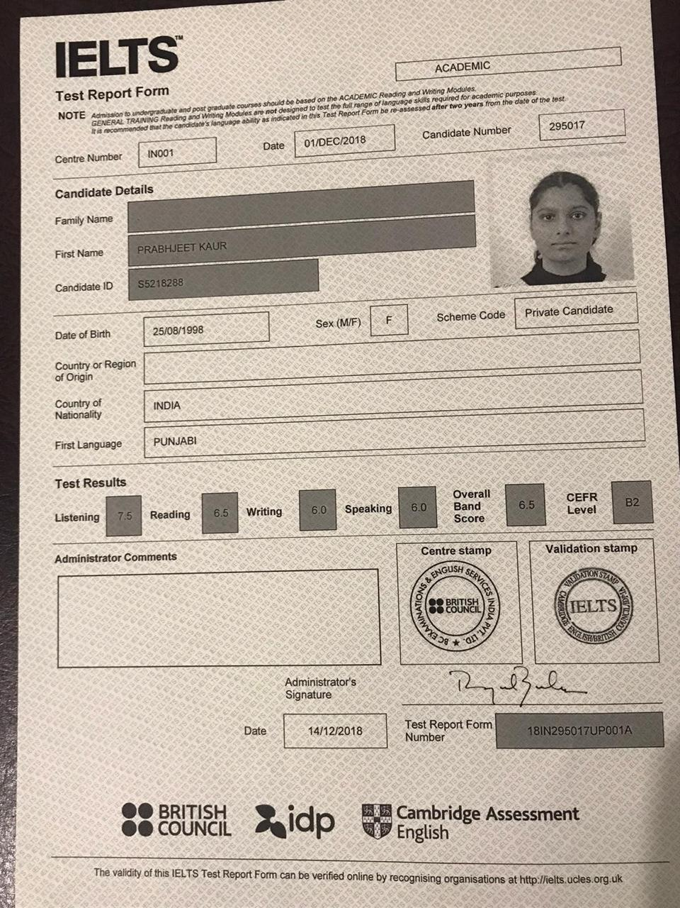

2016-17
Talwinder Kaur (UGC)
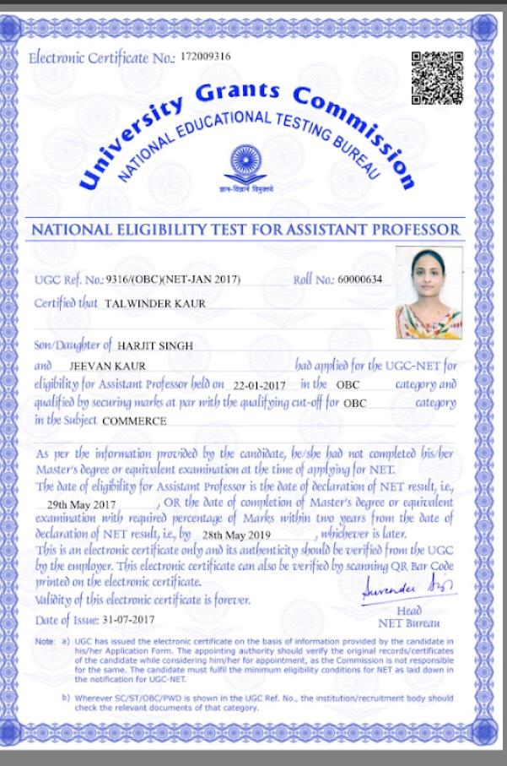

Lipika Dhingra (UGC)
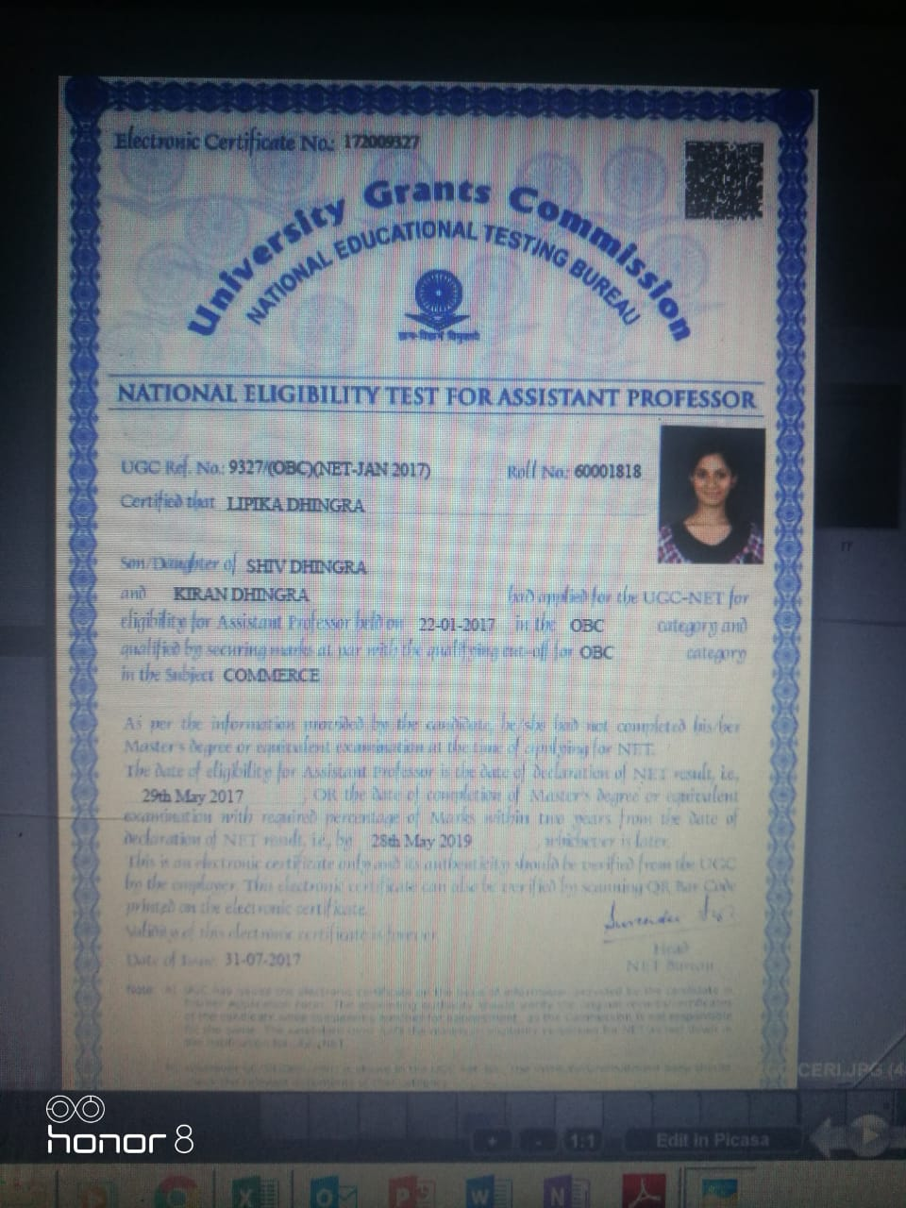

Garima (IELTS)
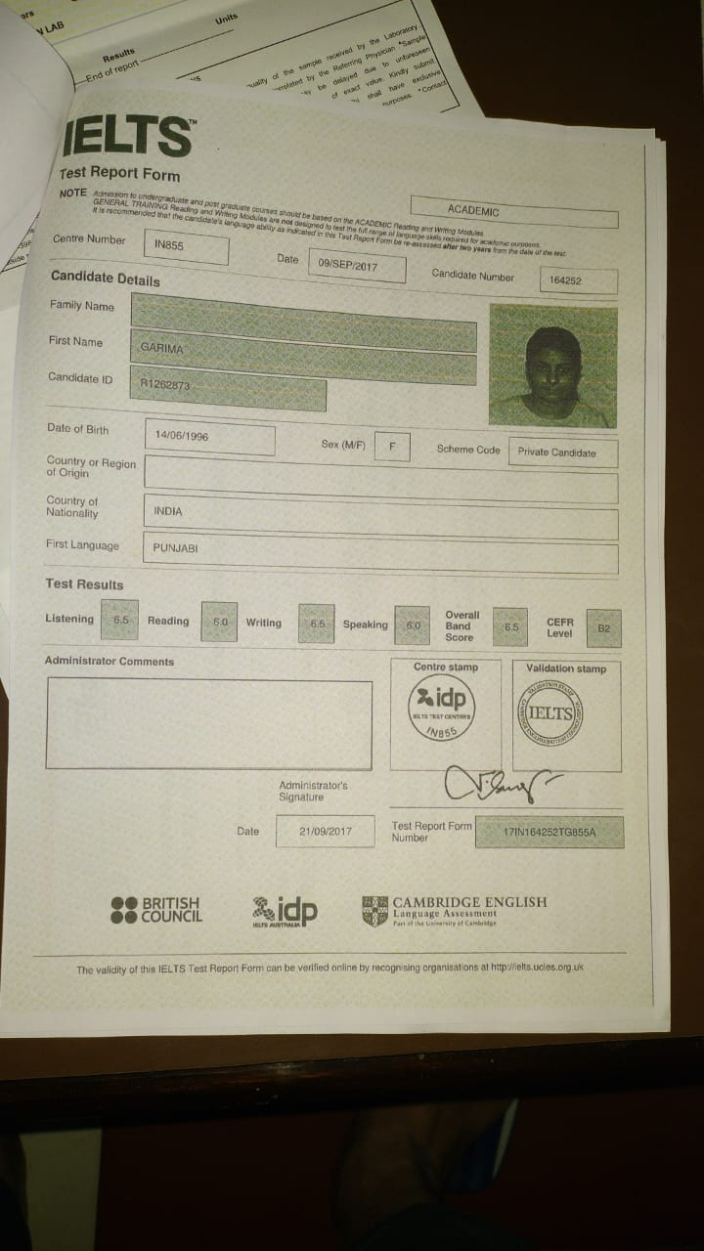

2015-16
Bhawna (UGC)
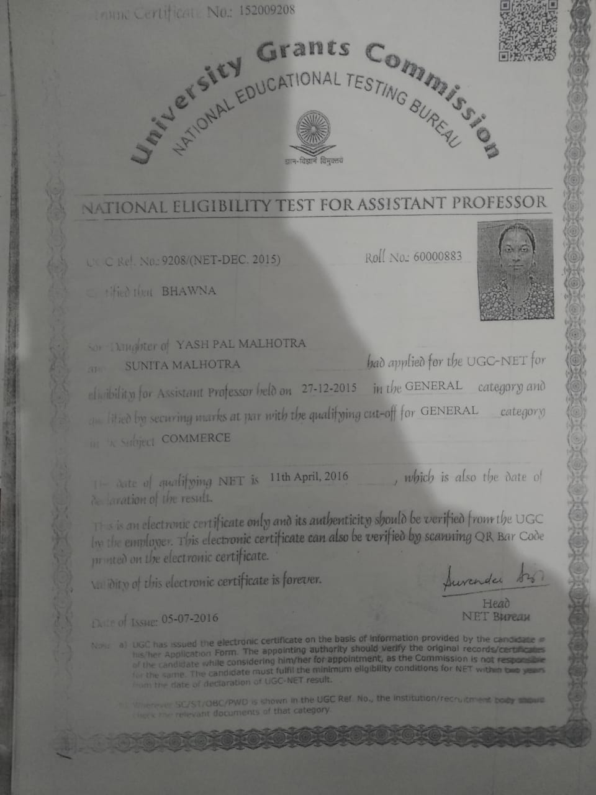

Indu Bala (MAT)
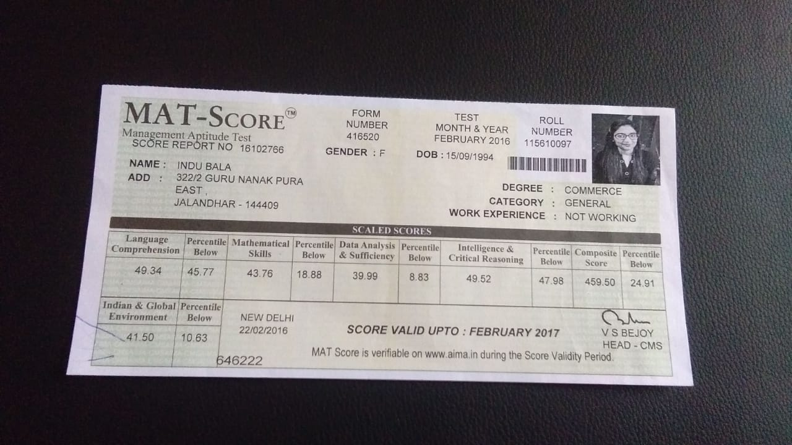

Navneet Kaur Bhullar (IELTS)
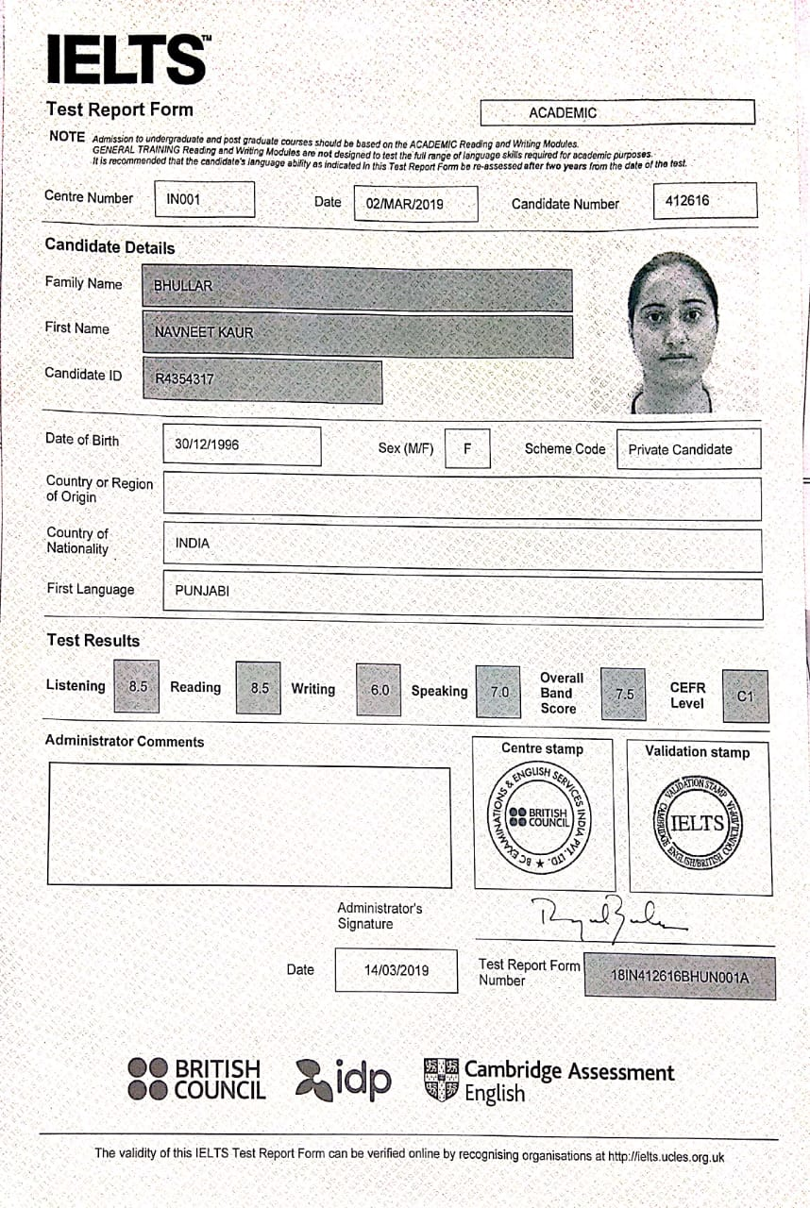

2014-15
Nidhi (UGC)
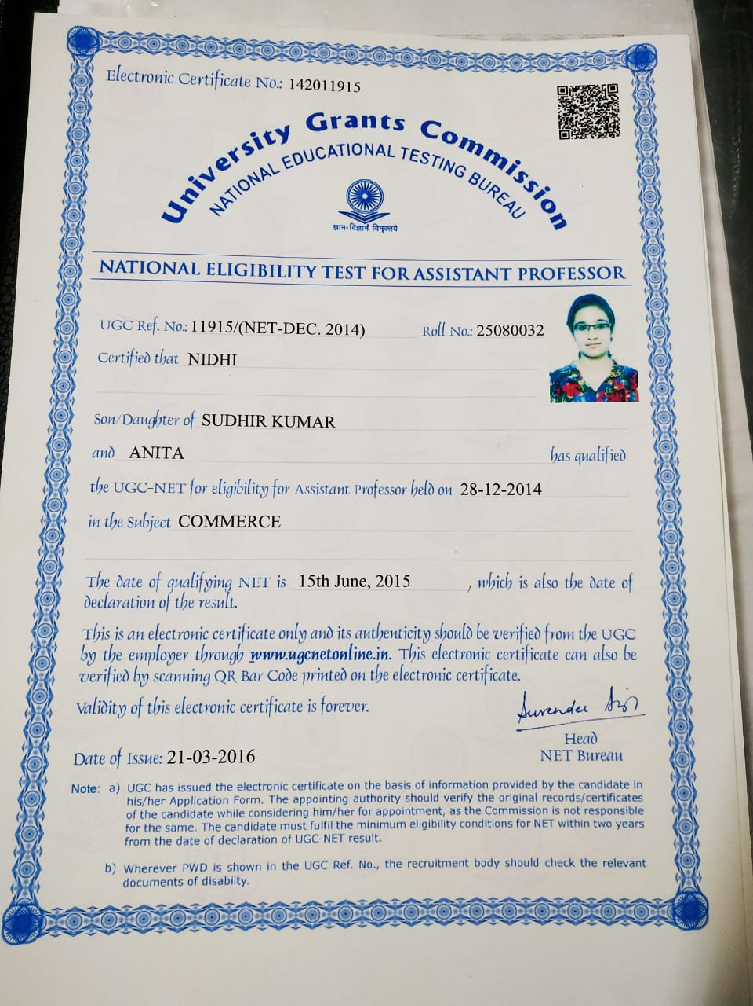

Jaspreet (PPSC)
